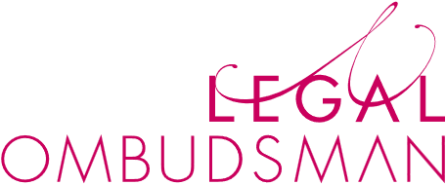

Making the MCRP your own
  - Model Complaints
Resolution Procedure

Version
Version | Description | Date
1.0 | First release of guidance | 29 July 2026

Introduction
We recognise that every legal service provider will have a complaints procedure today, and that will have been the product of careful thought, experience, knowledge of the client-base and knowledge of the skills within the business.

Even if LeO’s Model Complaints Resolution Procedure is attractive, we understand that some businesses and individuals would want to make some adjustments to the structure, for reasons specific to their own circumstances.

There is some flexibility in the MCRP for providers to make the procedure their own, whilst being able to describe the complaint procedure as being LeO’s and benefiting from the guidance and materials we’ve provided to support the MCRP.

To be able to say you’re using LeO’s Model Complaints Resolution Procedure on your website and in materials shared with consumers, there are five must-haves:

 | Must-Have | Why
1 | Link to the MCRP section of LeO website | Consumers need to know that your intention is to align with a procedure designed by LeO. We will update materials and consumers will be able to access them, gaining clear expectations on the process.  Link: https://www.legalombudsman.org.uk/for-legal-service-providers/learning-resources/model-complaints-resolution-procedure/
2 | Acknowledgment of receipt | An acknowledgment is essential to give everyone clarity that the MCRP has started. It also sets out the framework and timetable of what is to follow; something which all parties can rely on and refer to.
3 | An optional Early Resolution process | The focus of our MCRP is resolution. We encourage both parties to explore ways of resolving their dispute without the need for a lengthy, involved and expensive process. Replacing the first stage with a conversation or other interaction that drives at finding a way to resolve the complaint is a critical feature of MCRP. This stage must be in there, even if you exercise the option on an individual complaint not to use it.
4 | A Full Investigation process | The traditional final stage of a complaint procedure. Those complaints that need to go this far can still do so. It is the only required written stage of the process, after the acknowledgment.
5 | An outcome in writing | Whether the complaint is resolved in the Early Resolution stage or the Full Investigation, any outcome must be confirmed in writing. This provides certainty for both parties, and it is something which could be shared with us, if the complaint is later escalated.

Provided all five of these are in the procedure prominently, we are comfortable with you saying that you are looking for your procedure to align with LeO’s MCRP.

Expect that some consumers will compare your procedure with the MCRP and they will spot the differences, having looked at our website. It is likely wise to explain why any differences exist, so as to avoid any disputes on the procedure.

